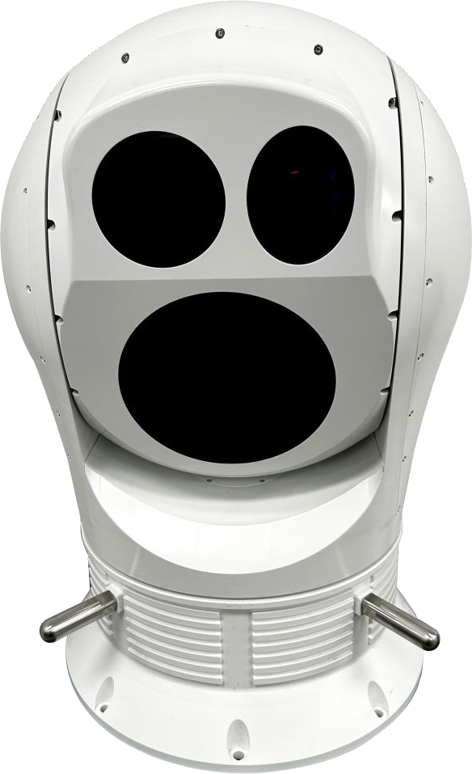


- High-quality cooled thermal imager
EOS-S520 Series
- With 14-bit digital thermal image output function

- With image tracking function

- With a 20 km laser range finder
- Pan: 360° continuous rotate, Tilt: –10° to +185°
- With a variety of continuous zoom thermal lens
- HD daylight camera with continuous zoom lens

- Can work with radar

- The positioning accuracy is up to 0.003°
- Achieves IP66 protection, suitable for com- plex weather conditions

EOS-S520 series thermal imaging system is a high-performance monitoring platform that integrates thermal imager with daylight camera and laser range finder, and has high protection levels. It can be fixed installing on ground base, vehicle-mounted or shipborne. It can be a stand-alone system or can be integrated into existing net-
works.

Configuration and Features
Thermal Camera
Thermal camera is equipped with cooled 640x512 MCT detector, it gives you clear crisp image with embedded ad- vance image processing technology. Combined with a 110-1100mm or 35-700mm continuous zoom lens, it is suitable for use in dark, complex weather conditions and provides clear thermal image for distant targets.

Daylight Camera
Daylight camera is equipped with 1/1.8” CMOS detector which provides more crisp detail and colorful image than that of 1/3”, it will also have more powerful ability to see target through fog and haze. A 60X optical zoom lens, up to focus 1200mm, is for extreme long range detection.
Pan-Tilt
S520 adopts high precision direct drive motor, which makes the equipment rotate more smoothly, position more ac- curate, response more timely. The positioning accuracy is up to 0.003°.

Image tracking function
Video tracking is based on a powerful video processor with powerful video processing and analysis functions and AI learning capabilities. It can process the video signal, overlay the system status character, and output to the monitor and video recorder through the form of network video stream. Through AI deep learning algorithm, it can realize the function of automatic identification and tracking of various targets. In tracking mode, the platform can automatically turn as the tracked target moves, and the user can select the target to track in the thermal or visible image.

Laser Range Finder
An eye safe Laser Range Finder is equipped in the system to detect the distance of the target up to 20Km.

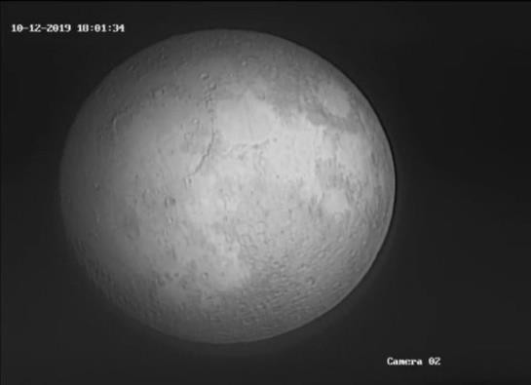
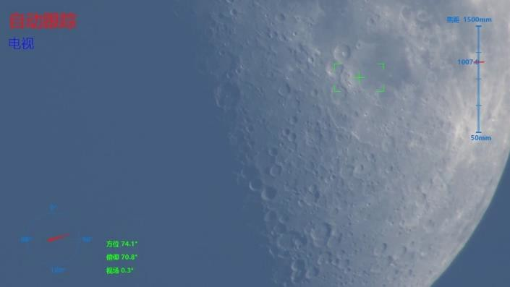

Technical Specifications

Model | EOS-520C | EOS-520CL
Thermal Camera
Detector Type | MCT cooled 640x512 FPA
Pixel | 15μm
Spectral Range | 3 - 5μm
Rate | 50Hz
NETD | ≤25mk
Focus Length | 35 - 700mm continuous zoom, 10X | 110 - 1100mm continuous zoom, 10X
FOV | 15.6°x 12.5° - 0.79°x 0.63° | 5°x 4° - 0.5°x 0.4°
F number | F4 | F5.5
Daylight Camera
Image Sensor | 1/1.8” CMOS
Resolution | 2048x1536, 3MP | 2688x1520, 4MP
Focus Length | 15-775mm continuous zoom, 52X | 20-1200mm continuous zoom, 60X
FOV | 26.5°×20° - 0.52°×0.39° | 22.1°×12.6° - 0.37°×0.21°
Focus | Auto/Manual/Semi-Auto
Video Output | Network & LVDS
Defog | Electronic-Defog / Optical-Defog
Pan-Tilt
Az Range | n×360°
EI Range | -10° - +185°
Maximum angular velocity | 120°/s
Maximum angular acceleration | 150°/s2
Positioning Accuracy | ≤0.005°
Drive Mode | Direct drive motor, High-speed start and stop
speed adaptive | Support lens focal length and rotation speed adaptive function
Preset | Programmable to 255 points
Scheduled Task | Preset Patrol / Linear Scan / Apple Peel Scan
Laser Range Finder
Range | 1535±5nm | 1570±5nm
Continuous Measuring Rate | 1~10Hz | 1~5Hz
Accuracy | ≤±2m（RMS） | ≤±5m（RMS）
Range | ≥12km ( for the target 2.3m x 2.3m) | ≥20km ( for the target 2.3m x 2.3m)

Tracking
Tracking Video | Support visible/ thermal image video switching tracking
Mode | Manual / Auto Tracking
Interface
Video Output | Two channels of network videos and one 14-bit digital thermal image
Control Interface | RJ45 / RS422
PTZ Control | Support Pelco-P, Pelco-D
Data Return | Can display real-time the azimuth angle and pitch angle of pan-tilt, as well as the focal length value and FOV of daylight camera and thermal camera
Power
Input Voltage | 48VDC±10%
Consumption | ≤500W(peak)
Environmental Specification
Operating Temperature | -40℃ ~ +60℃
Storage Temperature | -45℃ ~ +70℃
Humidity | ＜95%RH (no condensation)
IP Rating | IP66
Physical Characteristics
Size | ≤Φ520mm×785mm(H)
Weight | ≤95Kg

Range Performance for Thermal Camera
S520CL（with zoom lens 110mm - 1100mm）
Detection 17.9Km
Recognition 9.3Km
Identification 5.4Km

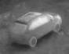
Detection 21.8Km
Recognition 15.3Km
Identification 10.7Km

